PID testing on prototype rover using motor encoders @ Mars Rovers Club, Boston University
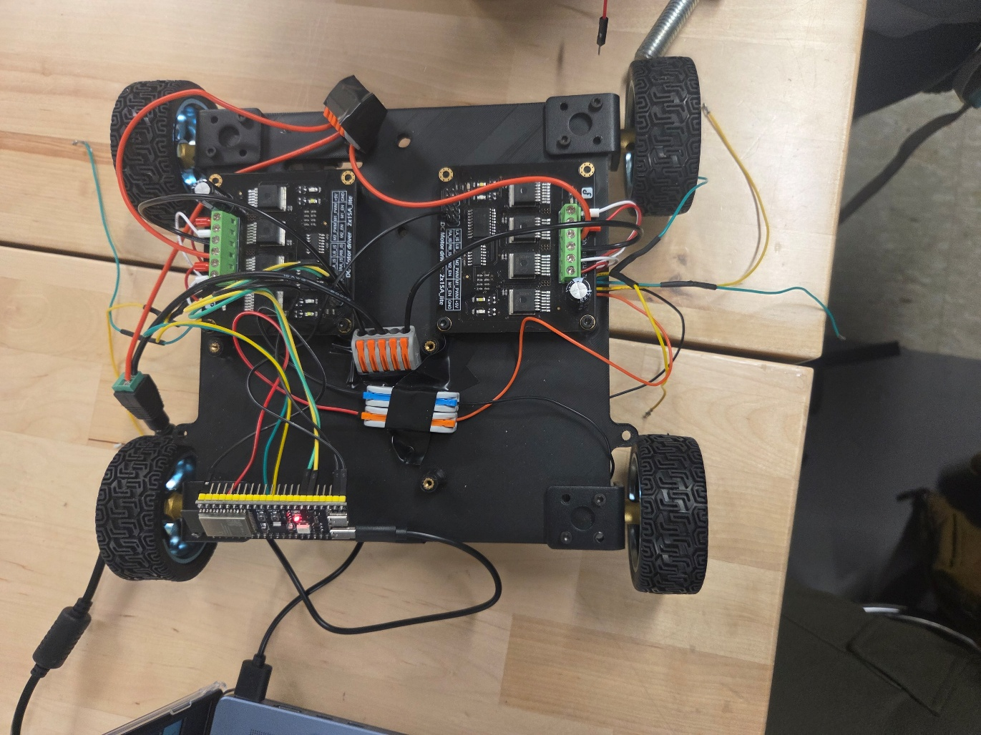

Motor driver testing @ Hack n’ Smash, Boston University

